Exp. 2. Simulation of Density of States of Quantum Well Structure withVarious Nanometer
Thickness.
Name : Kishore R
Reg No : 192512008

Aim: To simulate density of states of quantum well structure with various nano meter thickness

Case Study 1: Simulate the density of states of quantum well of thickness 0.5 nm
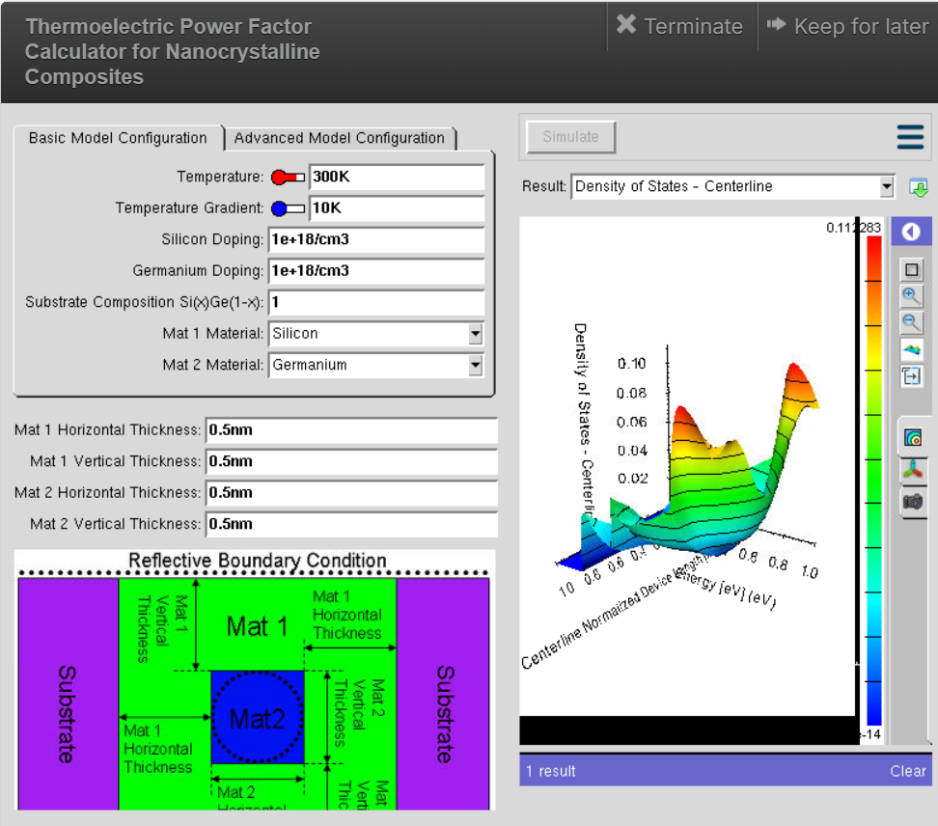

Case Study 2: Simulate the density of states of quantum well of thickness 0.6 nm
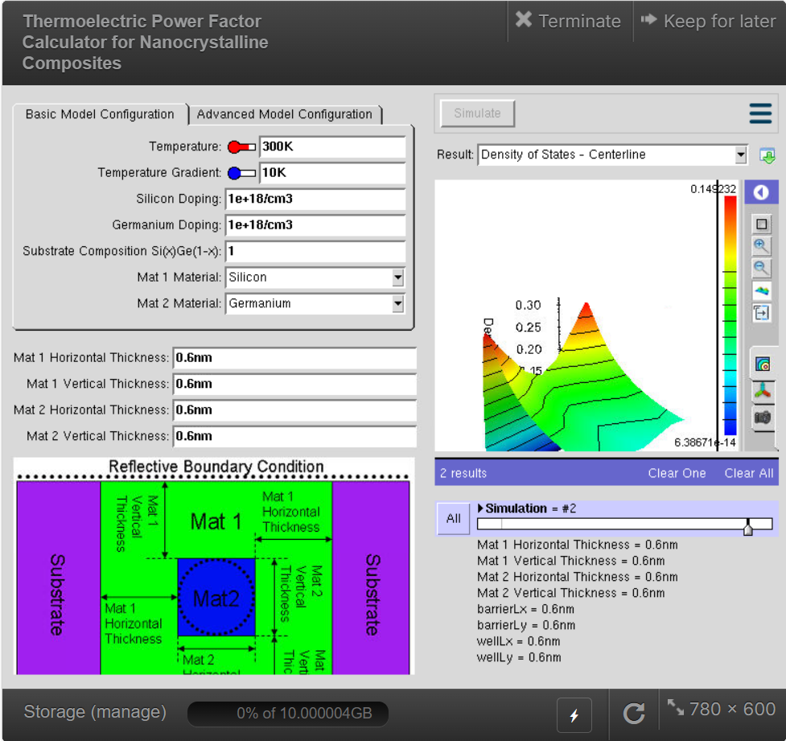

Result: Simulation of density of states of quantum well structure with various nanometre thickness is accomplished.

